Volzhskiy Zavod
Promyshlennoy Armatury

Flange pipe coupling
(flange adaptor)
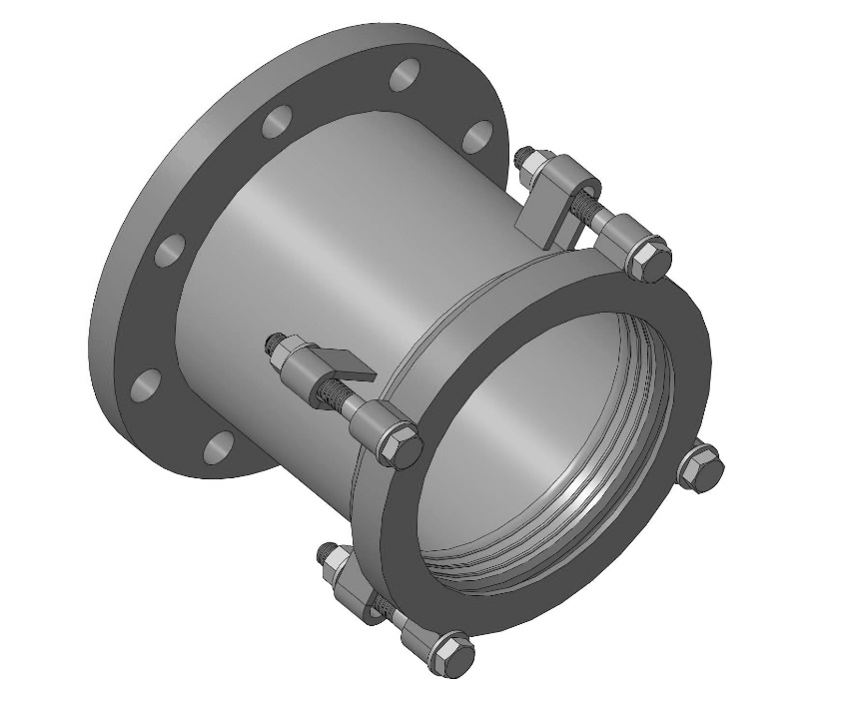
PRODUCT PASSPORT
TU (Technical specifications) 25.99.29-006-21203517-2018

2022
Flange pipe coupling (Flange adaptor)
1. General information
A flange adaptor is a type of mechanical fitting that allows access to a flange from a smooth pipe. Couplings are designed to connect steel, cast iron and asbestos-cement pipes with any elements of flange fittings. They are used on straight-line sections in sewage and water systems.
Medium temperature from 0°С to +110 °С.
Operating pressure: 1.0 MPa, 1.6 MPa, universal 1.0/1.6 MPa.
Manufactured for 50 to 1200 mm diameter pipes.
Maximum angular deviation up to 4°.
Mounting flange dimensions comply with GOST 33259-2015 (GOST 12820-80).
2. Product components.
The flange adaptor consists of a body, collars, caps, and metalware (Fig. 1).
The first standard version is made of metal or cast-iron clamp hub with a flange on the narrow side. The body is coated with a safety epoxy powder with a 250-micron thick layer. Coating color RAL5005.
The second standard version is made of AISI 304 stainless steel.
The collar is a ring cast out of EPDM rubber (GOST ISO 4097-2013).
The cap is a metal or cast iron ring with holes for studs. It is coated with a safety epoxy powder with a 250-micron thick layer. Coating color RAL5005.
Metalware is studs, nuts, and washers coated with a zinc safety coating. The studs have knurled threads. Each stud comes with a washer and a nut. The metalware strength index is not lower than 6.8. The size and number of studs are indicated in the specification sheet. Metalware is made of galvanized steel.
The flange pipe coupling can be manufactured of AISI 304 stainless steel, including caps and metalware.
The coupling is manufactured according to the current technical documentation of the manufacturer TU 25.99.29-006-21203517-2018, certificate of conformity No. 0013973

Fig.1  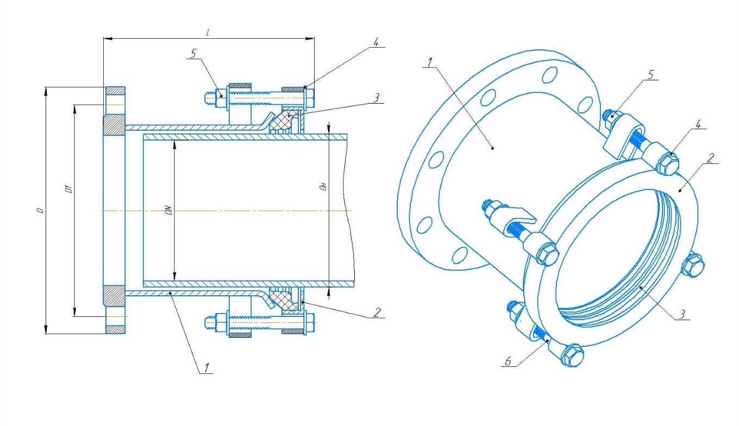 | № | Title
 | 1 | Body
 | 2 | Cap
 | 3 | Collar
 | 4 | Washer
 | 5 | Nut
 | 6 | Stud
3. Dimensions chart
Name | Body | DN, mm | Dн min, mm | Dн max, mm | D, mm 1 /1,6 MPa | D1, mm  1/1,6 MPa | L, mm | Stud
 | material |  |  |  |  |  | 1/1,6 MPa
PFRK-50-1 | metal | 50 | 53 | 68 | 160 | 125 | 179 | 2*М12
PFRK-50-2 | metal | 50 | 57 | 73 | 160 | 125 | 179 | 2*М12
PFRK-50 | cast iron | 50 | 59 | 72 | 160 | 125 | 145 | 2*М12
PFRK-65-1 | metal | 65 | 65 | 80 | 180 | 145 | 181 | 2*М12
PFRK-65-2 | metal | 65 | 72 | 85 | 180 | 145 | 181 | 2*М12
PFRK-80-1 | metal | 80 | 85 | 100 | 195 | 160 | 181 | 4*М12
PFRK-80-2 | metal | 80 | 88 | 105 | 195 | 160 | 181 | 4*М12
PFRK-100-1 | metal | 100 | 102 | 125 | 215 | 180 | 183 | 4*М12
PFRK-100-2 | metal | 100 | 106 | 130 | 215 | 180 | 183 | 4*М12
PFRK-100 | cast iron | 100 | 109 | 128 | 215 | 180 | 145 | 4*М12
PFRK-125 | metal | 125 | 125 | 149 | 245 | 210 | 185 | 4*М12
PFRK-150-1 | metal | 150 | 158 | 182 | 280 | 240 | 185 | 4*М12
PFRK-150 | cast iron | 150 | 159 | 182 | 280 | 240 | 145 | 4*М12
PFRK-175 | metal | 175 | 183 | 207 | 330 | 280 | 185 | 4*М12
PFRK-200-1 | metal | 200 | 205 | 229 | 335 | 295 | 222 | 6*М14
PFRK-200-2 | metal | 200 | 218 | 235 | 335 | 295 | 222 | 6*М14
PFRK-200 | cast iron | 200 | 218 | 235 | 335 | 295 | 145 | 6*М14
PFRK-225 | metal | 225 | 244 | 268 | 365 | 325/325 | 222 | 6*М14
PFRK-250-1 | metal | 250 | 270 | 294 | 405 | 350/355 | 223 | 6*М14
PFRK-250 | cast iron | 250 | 272 | 289 | 405 | 350/355 | 155 | 6*М14
PFRK-300 | metal | 300 | 315 | 340 | 460 | 400/410 | 223 | 6*М14
PFRK-300 | cast iron | 300 | 322 | 339 | 460 | 400/410 | 155 | 6*М14
PFRK-350-1 | metal | 350 | 351 | 375 | 520 | 460/470 | 225 | 8*М16
PFRK-350-2 | metal | 350 | 365 | 389 | 520 | 460/470 | 225 | 8*М16
PFRK-400-1 | metal | 400 | 390 | 414 | 580 | 515/525 | 229 | 8*М16
PFRK-400-2 | metal | 400 | 402 | 426 | 580 | 515/525 | 229 | 8*М16
PFRK-400-3 | metal | 400 | 418 | 442 | 580 | 515/525 | 229 | 8*М16
PFRK-500-1 | metal | 500 | 491 | 515 | 670/710 | 620/650 | 223/239 | 10*М16
PFRK-500-2 | metal | 500 | 505 | 529 | 670/710 | 620/650 | 223/239 | 10*М16
PFRK-500-3 | metal | 500 | 524 | 548 | 670/710 | 620/650 | 223/239 | 10*М16
PFRK-500-4 | metal | 500 | 553 | 577 | 670/710 | 620/650 | 223/239 | 10*М16
PFRK-600-1 | metal | 600 | 606 | 630 | 780/840 | 725/770 | 226/240 | 10*М16
PFRK-600-2 | metal | 600 | 630 | 654 | 780/840 | 725/770 | 226/240 | 10*М16
PFRK-700-1 | metal | 700 | 709 | 733 | 895/910 | 840/840 | 279/292 | 12*М16
PFRK-700-2 | metal | 700 | 718 | 742 | 895/910 | 840/840 | 279/292 | 12*М16
PFRK-700-3 | metal | 700 | 736 | 760 | 895/910 | 840/840 | 279/292 | 12*М16
PFRK-800-1 | metal | 800 | 796 | 820 | 1010/1020 | 950/950 | 282/294 | 12*М16
PFRK-800-2 | metal | 800 | 809 | 833 | 1010/1020 | 950/950 | 282/294 | 12*М16
PFRK-800-3 | metal | 800 | 817 | 841 | 1010/1020 | 950/950 | 282/294 | 12*М16
PFRK-800-4 | metal | 800 | 839 | 863 | 1010/1020 | 950/950 | 282/294 | 12*М16
PFRK-900-1 | metal | 900 | 899 | 923 | 1110/1120 | 1050/1050 | 285/299 | 14*М16
PFRK-900-2 | metal | 900 | 913 | 937 | 1110/1120 | 1050/1050 | 285/299 | 14*М16
PFRK-900-3 | metal | 900 | 919 | 943 | 1110/1120 | 1050/1050 | 285/299 | 14*М16
PFRK-900-4 | metal | 900 | 945 | 969 | 1110/1120 | 1050/1050 | 285/299 | 14*М16
PFRK-1000-1 | metal | 1000 | 996 | 1020 | 1220/1255 | 1160/1170 | 288/303 | 14*М16
PFRK-1000-2 | metal | 1000 | 1012 | 1036 | 1220/1255 | 1160/1170 | 288/303 | 14*М16
PFRK-1000-3 | metal | 1000 | 1016 | 1040 | 1220/1255 | 1160/1170 | 288/303 | 14*М16
PFRK-1000-4 | metal | 1000 | 1045 | 1069 | 1220/1255 | 1160/1170 | 288/303 | 14*М16
PFRK-1200-1 | metal | 1200 | 1200 | 1224 | 1455/1485 | 1380/1390 | 296/316 | 16*М16
PFRK-1200-2 | metal | 1200 | 1219 | 1243 | 1455/1485 | 1380/1390 | 296/316 | 16*М16
PFRK-1200-3 | metal | 1200 | 1255 | 1279 | 1455/1485 | 1380/1390 | 296/316 | 16*М16

4. Package set
Coupling assembly – 1 pc., product passport – 1 per lot
5. Product storage and transportation
Couplings are delivered pre-assembled and packed in corrugated cardboard boxes. Storage conditions of the product must comply with groups 1, 2 of GOST 15150-69. Use a covered vehicle during transportation and, if needed, additionally pack the product to avoid any significant deformation of the factory box and the clamp body
6. Installation instructions
Prior to installation, please make sure that the pipe on which you are going to assembly the coupling is clean. Attach the coupling onto the pipe with the flange facing out. Press the cover against the body while evenly tightening the nuts on the studs. Attach the required fittings to the flange.
7. Disposal
Upon the expiration of the service period, the product can be disassembled into parts: steel, rubber and sent for recycling, or you can dispose of in accordance with the procedure established at the enterprise where this product is used, drawn up in accordance with the Laws of the Russian Federation No. 96-FZ «On the Protection of Atmospheric Air”, No. 89-FZ “On Production and Consumption Wastes”, No. 52-FZ “On the sanitary and epidemiological well-being of the population”, and other Russian and regional regulations, acts, rules, orders, etc., which implement these laws.
8. Manufacturer’s warranty
The product that has been stored, installed, and operated according to this Product Passport has a 24-month warranty period from the date of its purchase. The expected service period is 10 years.
Manufacturer: "Volzhskiy Zavod Promyshlennoy Armatury" LLC, Samara region, Togliatti, Vokzalnaya str., 1a. tel. +7-987-430-22-11 (WhatsApp), www.vzpa.ru, info@vzpa.ru

